**READING**

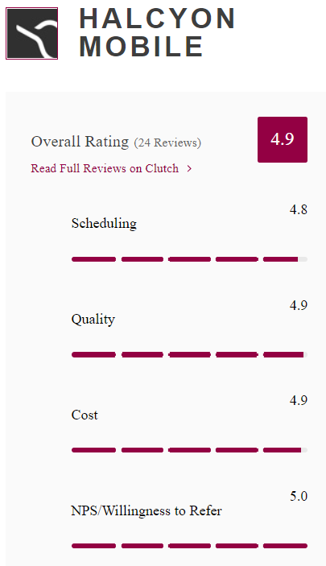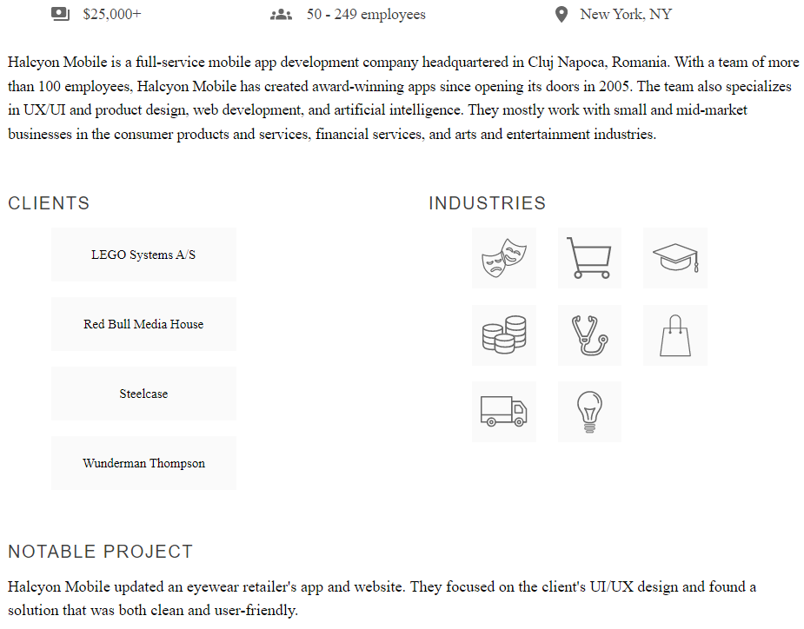

**1 - Read the text. Write true (T) or false (F). Justify false answers.**

1. Halcyon Mobile is based in Romania.
2. The company doesn´t have offices in other countries.
3. The company is 15-years-old.
4. The company has 100 employees approximately.
5. The company creates Apps.
6. The company works with small and big businesses.
7. The company works for various industries.
8. The notable project doesn´t provide an effective solution.
9. The company´s website is old.
10. The company has a low rating.

**NUMBERS**

**2 - Write the telephone numbers.**

**In numbers**

1. three five one, double four double six, eight seven nine oh ___________________________
2. four two nine, seventy-one thirty-eight, sixty-five forty-three _________________________

**In letters**

1. 0800 5498 1763 ___________________________________________________________
2. 249 468 7953 ______________________________________________________________

**EMAIL ADDRESSES**

**3 - Write the following email addresses:**

**In letters**

1. [Alex_Aziz@jump.jp](mailto:Alex_Aziz@jump.jp)

_____________________________________________________________________________

1. [sztulgit-k@bigio.org](mailto:sztulgit-k@bigio.org)

_____________________________________________________________________________

**In addresses**

1. capital s c n s, lowercase o f t , at, all lower case scn hyphen soft dot com

_____________________________________________________________________________

1. all lowercase info at all lower case v i r o n underscore i t dot com

_____________________________________________________________________________

**HAVE GOT**

**4 - Complete the sentences with HAVE/** **HAVEN´T/ HAS / HASN´T.**

1. Your computer __________________ got a fast processor. (+)
2. __________________ these companies got a good software?
3. This computer __________________ got an updated anti-virus. (-)
4. The offices __________________ got printers. (+)
5. __________________ the manager got a modern computer?
6. Peter and Laura __________________ got new mobiles. (-)

**PRESENT SIMPLE OF TO BE (am, is are …)**

**5 - Complete with the correct form of the verb TO BE.**

1. Claire **_____________** in the company. (-)
2. **_____________** Samat the office today?
3. I _____________ from San Francisco. (+)
4. The topic **_____________** fascinating.(+)
5. The documents **_____________** in the pendrive. (-)
6. _____________ they in a videocall?

**PRESENT SIMPLE**

**6 - Choose the correct option.**

1. Jack and I **develop / develops** clients´ website.
2. **Does Sam take / Sam takes** time to implement new platforms?
3. He doesn´t **does / do** research on new technologies.
4. Laura and Peter **collaborates / collaborate** with content creators.
5. Does she **reviews / review** their day´s work in the afternoon?
6. They **don´t / doesn**´t attend meetings to discuss projects.

**PRESENT SIMPLE**

**7 - Complete the text with the correct form of the verbs in brackets.**

**Tricia ´s Routine**

Tricia is a developer. She 1 ___________________ (prepare) for the day. She 2 ___________________ (drive) to work. Then, she 3 ___________________ (check) emails for the first time of the day. She 4 ___________________ (get) back to any urgent requests and she also 5 ___________________ (organize) daily tasks. She 6 ___________________ (discuss) her ideas with her boss.

**WRITING**

**8 - Look at the table about Soft Labs. Write a description of the company.**

| **Company Name** | Soft Labs |
| --- | --- |
| **Business** | a web and mobile app development company |
| **Head office** | Los Angeles, USA |
| **Branch offices** | 0 (zero) |
| **Staff** | 50 employees |
| **Activities** | **provide** product strategy, UX/UI design and IoT development services |
| **Some Clients** | World Health Organization, World Wildlife Fund, USC, UCLA |
| **Present Project** | **design** and **develop** a mobile app for a sports stock market |
| **Website** | https://softlabs.com/ |

Start like this:

*Soft Labs is* a web and mobile app development company. The head office is based in Los Angeles. It doesn´t have branch offices. The company has 50 employees. It provides product strategy, UX/UI design and IoT development services. The clients are World Health Organization, World Wildlife Fund, USC and UCLA. The current / present project is to design and develop a mobile app for a sports stock market./ The company designs and develops a mobile app for a sports stock market. The website is softlabs.com.

________________________________________________________________________________